



**Obstacles**

* Limited Time to Research/Read Documentation
* After Hours to Need Help
* New Client

**Wants/Needs**

* Easy Access to Common Information
* 24 Hr Customer Assistance
* Child Lock/Security

**Savviness Scale**

(1 Star through 5 Stars)

Internet 

Streaming 

Research 

Device Variability 

**Helpful Suggestions**

Navigate to StarsStreaming Homepage

**Demographics**

Amelia Korning

30 Years Old

Female

New York, USA

Customer Service Representative

Associates in Communications

**Biography**

Amelia is a mother of two children; One 2 year old boy and one 5 year old girl. Currently lives in New York state and is a Customer Service Representative for a Telephone Company. Received her Associates in Communications at Caygua Community College. Amelia is a potential new customer looking to learn how to subscribe to the service.

**Favorite Movies & Shows**

* Practical Magic
* The Little Mermaid
* Under the Tuscan Sun
* Friends

**Childrens’ Favorite Movies & Shows**

* Frozen
* Trollz
* Bluey

Contact Customer Support

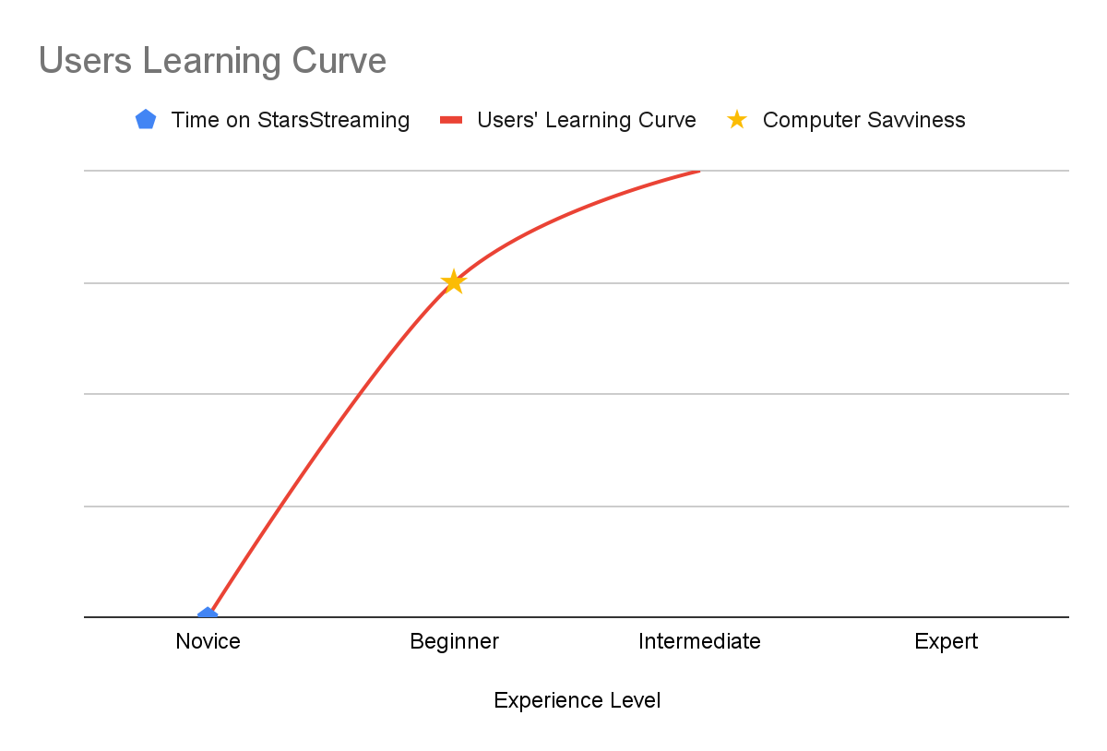

**Chart Description**

This chart displays the learning curve of the persona above.

This line shows the delta of no Experience on StarsStreaming versus the Persona’s Computer Savviness which gives the visual of the learning curve.